Fossil-Paleo-Mammoth-**Mammuthus primigenius**-Molar-Yakutia, Northern Siberia, Russia

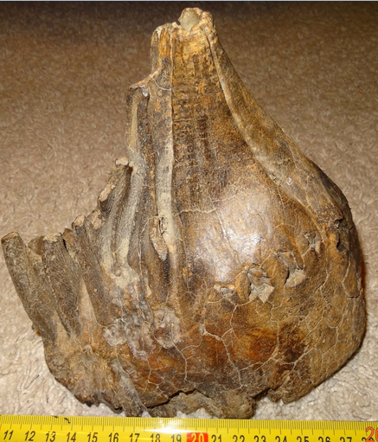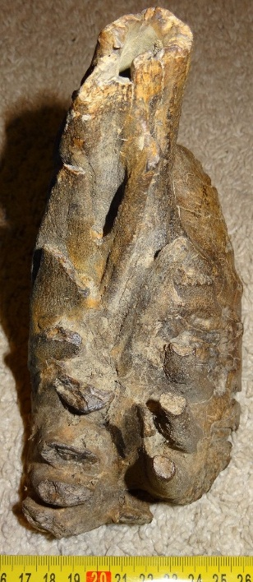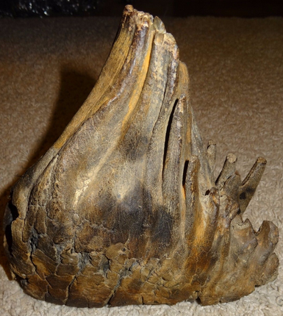

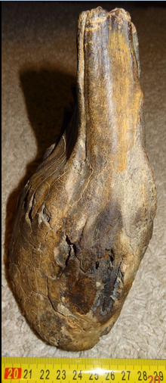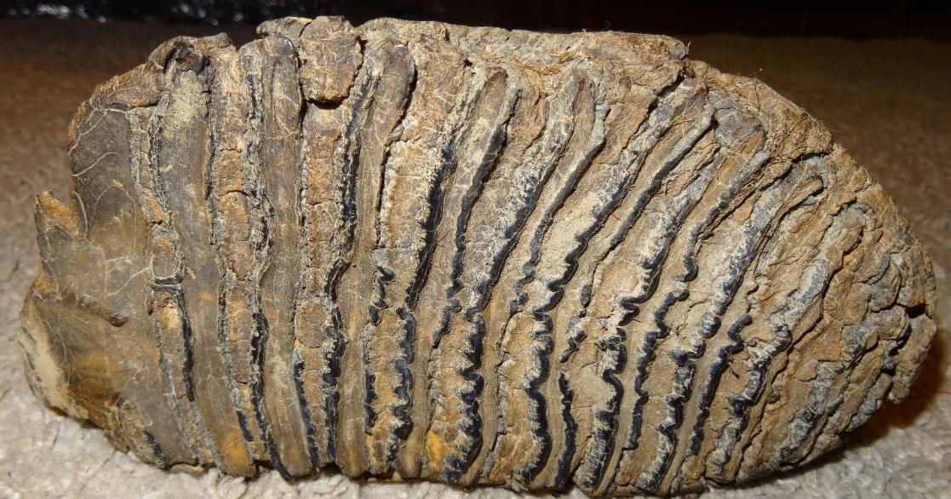

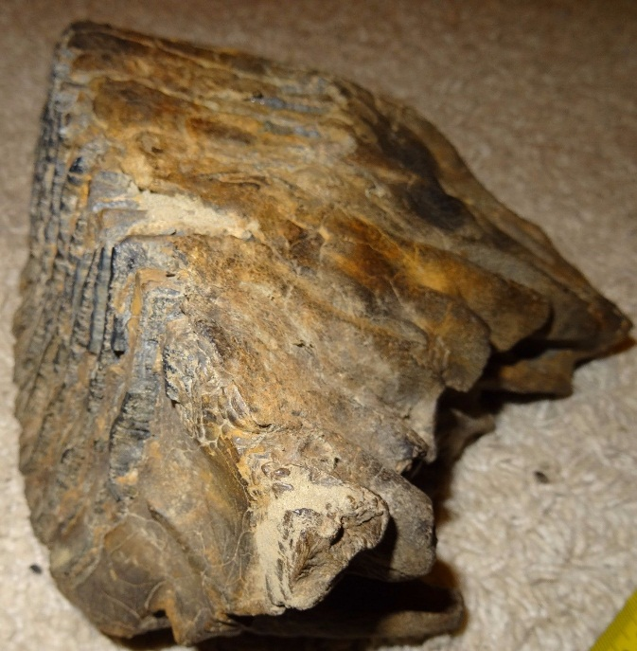

**Formal Label:** Mammoth-**Mammuthus primigenius**-Molar-Yakutia, Northern Siberia, Russia-50,000 BP

**Accession Number:**

**LC Classification:**

**Date or Time Horizon:** 50,000 BP

**Geographical Area:** Yakutia, Northern Siberia, Russia

**Cultural Affiliation:** Pleistocene

**Medium:** Fossil

**Dimensions:   
Weight:** 2334 gm

**Provenance: Andrey Budnikov,** Yakutia, Northern Siberia, Russia

**Condition: Museum Quality**

**Discussion: Rare to have the roots so perfectly attached. The Mammoth only had a single tooth in each jaw, four total with six sets of replacements over its lifetime.**

The **woolly mammoth** (*Mammuthus primigenius*) is a species of [mammoth](https://en.wikipedia.org/wiki/Mammoth) that lived during the [Pleistocene](https://en.wikipedia.org/wiki/Pleistocene) epoch, and was one of the last in a line of mammoth species, beginning with *[Mammuthus subplanifrons](https://en.wikipedia.org/wiki/Mammuthus_subplanifrons" \o "Mammuthus subplanifrons)* in the early [Pliocene](https://en.wikipedia.org/wiki/Pliocene). The woolly mammoth diverged from the [steppe mammoth](https://en.wikipedia.org/wiki/Steppe_mammoth) about 400,000 years ago in eastern Asia. Its closest extant relative is the [Asian elephant](https://en.wikipedia.org/wiki/Asian_elephant). The appearance of the woolly mammoth is probably the best known of any prehistoric animal due to the many frozen specimens with preserved soft tissue and depictions by contemporary humans in their art. Fully grown males reached shoulder heights between 8.9 and 11.2’ (2.7 and 3.4 m) and weighed up to 6 tons. Female woolly mammoths reached 8.5-9.5’ (2.6–2.9 m) in shoulder heights and were built more lightly than males, weighing up to 4 [tons](https://en.wikipedia.org/wiki/Tonne). A newborn calf would have weighed about 200 lbs (90 kg). It had long, curved [tusks](https://en.wikipedia.org/wiki/Tusk) and four [molars](https://en.wikipedia.org/wiki/Molar_%28tooth%29), which were replaced six times during the lifetime of an individual. Its behavior was similar to that of modern elephants, and it used its tusks and trunk for manipulating objects, fighting, and foraging. The diet of the woolly mammoth was mainly grass and [sedges](https://en.wikipedia.org/wiki/Cyperaceae). Individuals could probably reach the age of 60. Its habitat was the [mammoth steppe](https://en.wikipedia.org/wiki/Mammoth_steppe), which stretched across northern Eurasia and North America.

The woolly mammoth coexisted with early humans, who used its bones and tusks for making art, tools, and dwellings, and the species was also hunted for food. It disappeared from its mainland range at the end of the Pleistocene 10,000 years ago, most likely through climate change and consequent shrinkage of its habitat, hunting by humans, or a combination of the two.

Woolly mammoths had four functional molar teeth at a time, two in the upper jaw and two in the lower. About 9” (23 cm) of the crown was within the jaw, and 1” (2.5 cm) was above. The crown was continually pushed forwards and up as it wore down, comparable to a conveyor belt. The teeth had up to 26 separated ridges of enamel, which were themselves covered in "prisms" that were directed towards the chewing surface. These were quite wear resistant and kept together by cementum and dentine. A mammoth had six sets of molars throughout a lifetime, which were replaced five times, though a few specimens with a seventh set are known. The latter condition could extend the lifespan of the individual, unless the tooth consisted of only a few plates.

The first molars were about the size of those of a human, ½” (1.3 cm), the third were 6” (15 cm) long, and the sixth were about 1’ (30 cm) long and weighed 4 lbs (1.8 kg). At the age of 6–12 months, the second set of molars would be in the process of erupting, and the first set would be worn out at 18 months of age. The third set of molars lasted for ten years, and this process was repeated until the final, sixth set emerged when the animal was 30 years old. When the last set of molars was worn out, the animal would be unable to chew and feed, and it would die of starvation. The molars grew larger and contained more ridges with each replacement. The woolly mammoth is considered to have had the most complex molars of any elephant.

**References:**

|  |  |  |  |  |  |  |  |  |  |  |  |  |  |  |  |  |  |  |
| --- | --- | --- | --- | --- | --- | --- | --- | --- | --- | --- | --- | --- | --- | --- | --- | --- | --- | --- |
| **Order information**   |  |  | | --- | --- | | Buyer | 802-867 | | Seller | budnikof | | Order placed on | Tuesday, Jan 31, 2017 | | Payment method | PayPal | | Payment date | Tuesday, Jan 31, 2017 | | **Shipping address**  **Ralph J Coffman Jr**  149 Atlantic Ave  Swampscott MA 01907-2427  United States | **Order total**   |  |  | | --- | --- | | Subtotal | $181.50 | | Shipping | $40.00 | | Total | $221.50 | |
|  |  |  |
| **Item(s) bought from budnikof**   | **Qty** | **Item name** | **Shipping service** | **Item price** | | --- | --- | --- | --- | | 1 | Impressive Tooth of a Woolly Mammoth FOSSIL Pleistocene Museum Quali (262817013893) | Expedited Shipping from outside US | $181.50 | | | |